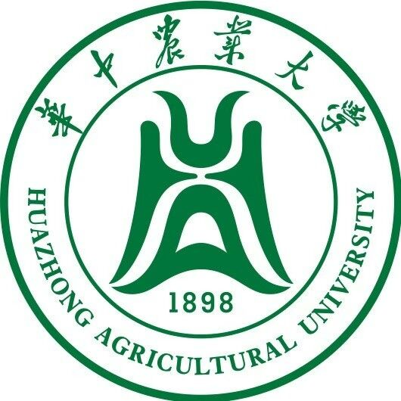

[AILA 2024 & Symposium]
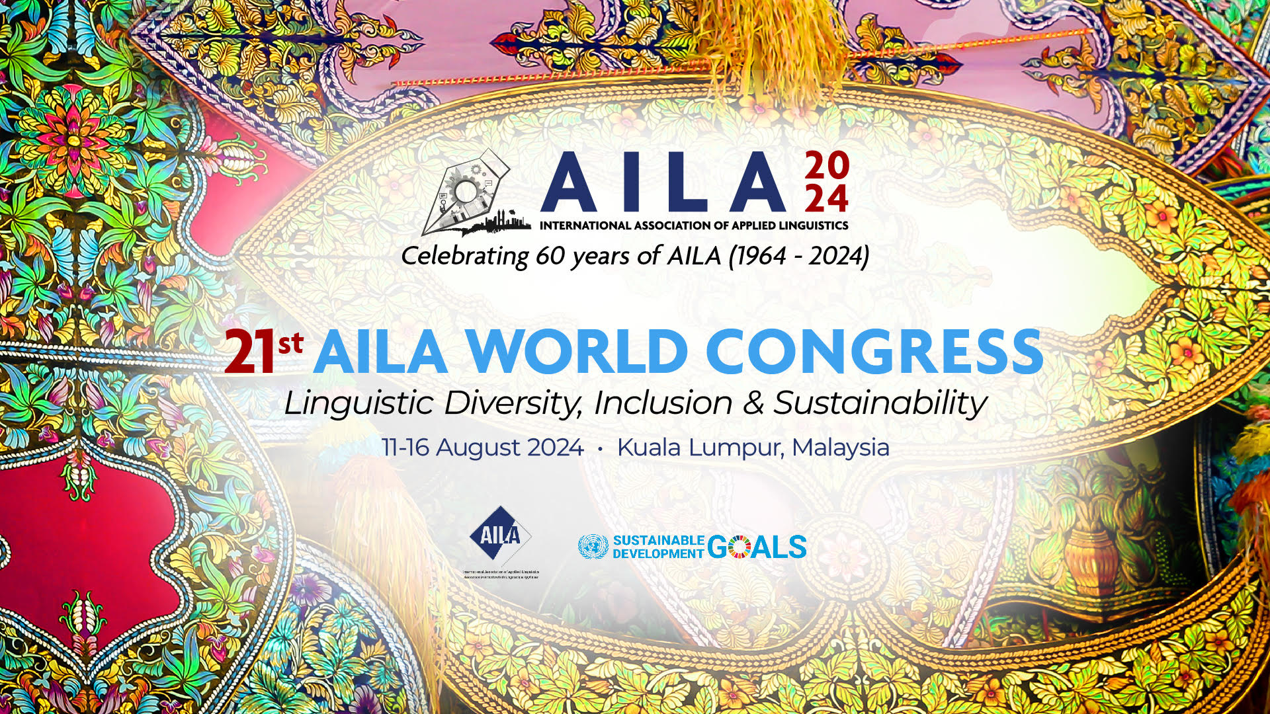
Innovating Digital Lexicography in the Era of Media Convergence

Modality of Symposium: hybrid (online & onsite)

Place and date : 11-16 August 2024 in Kuala Lumpur, Malaysia

Coordinators:
CHEN Lian 陈恋 (LLL UMR 7270 CNRS laboratory - Orleans University & LT2D- Jean Pruvost center EA7518, Cergy Paris University, France)

GENG Yundong 耿云冬(Associate professor, Huazhong Agricultural University, China)

Language: English

Arguments：
“Digital corpus and lexicometric tools have profoundly revolutionized linguistic research and, more particularly, lexicographic research, by multiplying the possibilities of observations.” (Hausmann and Blumenthal 2006: 11). Media convergence presents a significant opportunity for the digital transformation of dictionaries. With the advent of new media, dictionaries can now offer a variety of ways to present content, including text, images, sound, and video. Additionally, hyperlinks enable users to quickly access supplementary data. New media constitute two-way interactive platforms, sometimes free and open, where users can obtain information, interact with it and even disseminate it when and where they want.

This symposium aims to explore various digital (meta-)lexicographic projects worldwide that involve designing, producing, and using dictionaries. These projects should take into account the available technologies, but especially the possibilities “opened up by digital culture which allows flexibility in the processing of data in addition to adding oral and image contributions to writing” (Remysen and Vincent, 2021). It deals with the current distribution of media (online and in paper format), as well as with the new practices of digital lexicography: coexistence of ancient and modern editions, data access, content aggregation, collaborative dictionaries, etc.

The researcher should explore and create new concepts or hypotheses for an improved and innovative dictionary. We are interested in, including but not limited to, innovations in digital (meta-)lexicography, exploration of new approaches to lexicography, innovations in lexicographic forms, etc., monolingual, bilingual and multilingual, examination of the user needs in the digital revolution, carried out in a dynamic of linguistic revitalization and elaboration, and which contribute to the creation of new content.

Project leaders and scientific research institutes are invited to discuss and present the main advances in digital dictionaries, and related applications, which bring visibility to languages and cultures in particular.

